KAFKA

What is Kafka?
Kafka is a distributed streaming platform:
– publish-subscribe messaging system.
A messaging system lets you send messages between processes, applications, and servers.
– Store streams of records in a fault-tolerant durable way.
– Process streams of records as they occur.
Kafka is used for building real-time data pipelines and streaming apps.
It is horizontally scalable, fault-tolerant, fast and runs in production in thousands of companies.
Originally started by LinkedIn, later open-sourced Apache in 2011.

Key Components of Kafka
- Broker
- Producers
- Consumers
- Topic
- Partitions
- Offset
- Replication

Broker
Apache Kafka runs as a cluster on one or more servers that can span multiple data centers. An instance of the cluster is broker. Brokers are simple system responsible for maintaining the published data. Each broker may have zero or more partitions per topic. Assume, if there are N partitions in a topic and N number of brokers, each broker will have one partition.

Producers
Producers are the publisher of messages to one or more Kafka topics. Producers send data to Kafka brokers. Every time a producer publishes a message to a broker, the broker simply appends the message to the last segment file. The message will be appended to a partition. Producer can also send messages to a partition of their choice.

Consumers
Consumers read data from brokers. Consumers subscribes to one or more topics and consume published messages by pulling data from the brokers.

Topic
A stream of messages belonging to a particular category is called a topic. Data is stored in topics. Topics are split into partitions. For each topic, Kafka keeps a minimum of one partition. Each such partition contains messages in an immutable ordered sequence. A partition is implemented as a set of segment files of equal sizes.

Partitions
Kafka topics are divided into a number of partitions, which contains messages in an unchangeable sequence(immutable).
Each message in a partition is assigned and identified by its unique offset.
A topic can also have multiple partition logs. This allows for multiple consumers to read from a topic in parallel.

Offset
Messages in the partitions are each assigned a unique (per partition) and sequential id called the offset. Consumers track their pointers via (offset, partition, topic) tuples.

Replication
In Kafka, replication is implemented at the partition level. Helps to prevent data loss. The redundant unit of a topic partition is called a replica.
Each partition usually has one or more replicas meaning that partitions contain messages that are replicated over a few Kafka brokers in the cluster.

Kafka Flow
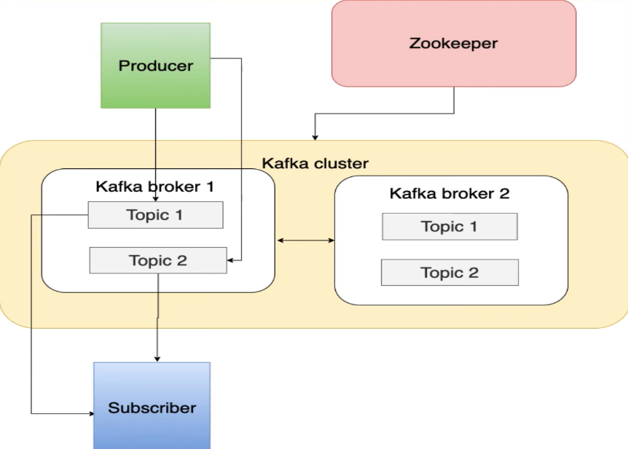

Cluster Creation with Console?

Create the Cluster
- Sign-in to the AWS Console in the account you want to create your cluster in
- Browse to the MSK create cluster wizard
- to start the creation
- Select Custom create for the Creation method.
- Enter the cluster name .
- Select the version of Kafka you want to run on the cluster.

Brokers
- Select kafka.m5.large (or your desired instance type) as the Broker Instance Type
- Select the number of zones (availability zones) you want to deploy in to (3)
- Enter 1 for the number of brokers per zone.

Storage
- Enter 100 GiB

Create Configuration Object
- Select Custom configuration for the Cluster configuration.
- Click on Create configuration.
- Give your configuration a name.
- Add a description
- Under Configuration Properties, ensure the following options are set/overridden - you can leave the Version as None
  - auto.create.topics.enable=true
  - delete.topic.enable=true
  - log.retention.hours=8

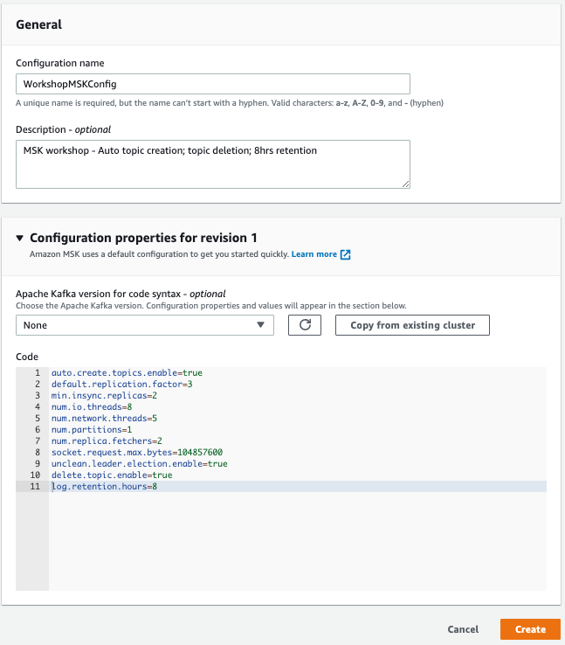



Networking Section
- Select the VPC you want to deploy your cluster. For example, if the VPC resides in us-east-1.
- Select us-east-1a for the first Availability Zone (AZ), then the subnet
- Select us-east-1b for the second AZ, and the appropriate subnet.
- Select us-east-1c for the third AZ, and the appropriate subnet.

Security Group
Create a new security group or select the existing one with necessary rules added.

Access control Authentication
Select Unauthenticated access for Access control methods. Leave the other access control methods blank.
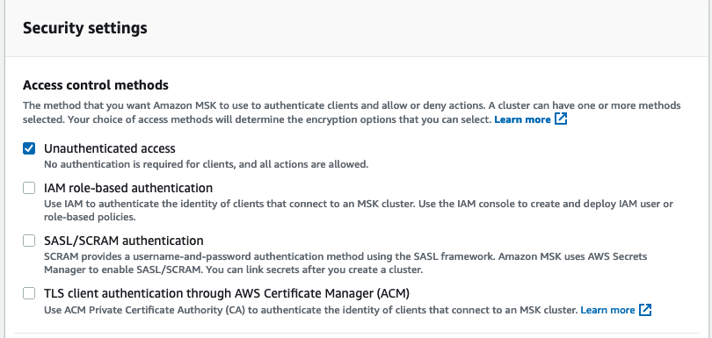

Encryption
- In the Encryption section, select both TLS encryption and Plaintext for encryption between clients and brokers. This will enable 2 different service ports on the cluster (9092 and 9094). You will be able to communicate in both an encrypted and unencrypted manner - choose based on your data needs. For this workshop we will experiment with both, but you should choose what fits your production environment best.
- Select TLS encryption for encryption within the cluster.
- Select Use AWS managed key. This means Amazon MSK will manage the encryption key for you.
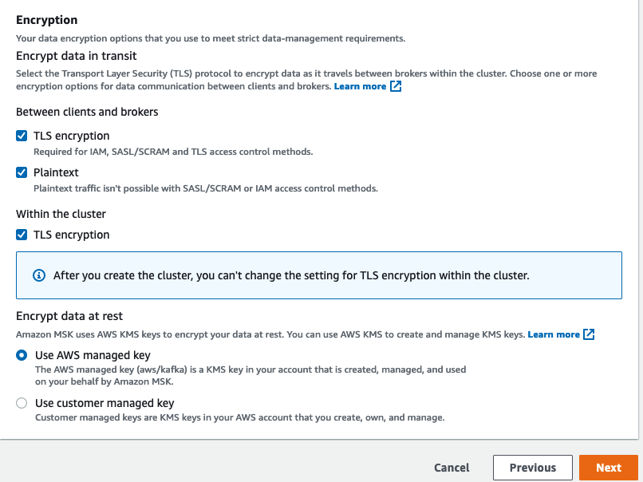
- Click Next

Monitoring
- There are 2 types of monitoring available for Amazon MSK - CloudWatch monitoring which is available in 4 flavors (Basic, Enhanced broker-level, Enhanced topic-level, and Enhanced partition-level).
- Select Basic Monitoring

Broker Log Delivery
We are going to configure the cluster to send any broker logs to CloudWatch Logs, which will provide us with an easy way to work with the logs.
- Click Deliver to Amazon CloudWatch Logs - this will expand a new section where you will enter the ARN for the log group. To do this we will need to create a log group first.
- Click on visit Amazon CloudWatch Logs console - this will open a new tab in the CloudWatch Logs console.
- Click on Create Log Group in the top right corner.
- Enter your log group name and click Create.
- You can now close this tab.
- You should be back in your MSK Cluster Creation window - click Browse button, and then check the circle beside loggroupname and then click Choose.

Cluster Tags
- Under key enter Name and in value.
- Click Next

Review and Create
Scroll to the bottom and click Create cluster.

Working with Kafka
Pre-Requisites
- Java JVM
- Kafka source/binary files
- Link jvm cacert folder with kafka
  - Copy the path of the cacert folder under jvm open jdk and create a tmp file.
  - sudo cp /usr/lib/jvm/jre-1.8.0-openjdk/lib/security/cacerts /tmp/kafka.client.truststore.jks
  - Traverse back to kafka folder and under bin create a new file with name client.properties and enter the following.
    - security.protocol=SSl
    - ssl.truststore.location=/tmp/kafka.client.truststore.jks
Describe the Kafka and copy the zookeeper URL or get it from the Console.
- aws kafka describe-cluster --region <region-name> --cluster-arn <arn of the Cluster>
Create a Topic
Traverse to the path where kafka is downloaded.
- bin/kafka-topics.sh --create --zookeeper "zookeeper URL" --replication-factor 2 --partitions 1 --topic <topic-name>
List Topic
- bin/kafka-topics.sh --list --zookeeper "zookeeper URL"
Delete Topic
- bin/kafka-topics.sh --zookeeper "zookeeper URL" --delete --topic <topic-name>
Get Bootstrap Details
- aws kafka get-bootstrap-brokers --cluster-arn <arn of the cluster>--region <region-name>
Open two sessions one for producer and one for consumer
In the Producer session enter the following command to start producing messages.
Traverse into the bin folder under kafka and run this command.
- ./kafka-console-producer.sh --broker-list "bootstrap url" --producer.config client.properties --topic <topic-name>

In the Consumer session enter the following command to start producing messages.
Traverse into the bin folder under kafka and run this command.
- ./kafka-console-consumer.sh --bootstrap-server "bootstrap url" --consumer.config client.properties --topic demotopic --from-beginning

The messages entered on the Producer session will be available on the consumer.

